Progress Tracker

An Agent-Based Model of Urban Economics:

Evaluating Emergence & Evolution

|  |  |  |  |  |  |
| --- | --- | --- | --- | --- | --- |
| **Week** |  | **Feature** | **Explanation** | **Issues** | **Status** |
| 1 | Landlords | Build Land Area |  | Landlords placed at random on map in setup, travel random directions around map claiming free space. |  |
|  |  |  | Cellular Automata | Very slow loading | Fixed: Uses standard method to create patch until certain percentage, then uses cellular automata to fill in remaining space around the patches. |
|  |  | Colouration/ Ownership |  | When creating their own land area, if there was a single patch left within their land they had to travel around at random to find it. | Fixed: If all 4 neighbours (NSEW) were belonging to the same landlord, it will change. |
|  |  |  |  |  |  |
|  |  | Land Costs | Assigned to patches | Not assigning land costs correctly | Fixed |
|  |  |  |  |  |  |
|  | Firms | Wage output | Randomised number for the wage gap based on the number of firms. |  | Extend: When the radius is decreased below the limit that allows all firms to be placed within it, reduce the maximum amount of firms on parameter slider. |
|  |  |  |  | Overlapping firms. | Fixed: “in-radius” – each firm claims the space around them so they are unable to stack. |
|  |  | Place within Radius of City |  |  |  |
|  |  |  | Balancing of the variables in reference to goals on paper is important for viewing the movement of people. | Limited movement |  |
|  |  |  |  |  |  |
|  | People | Love of Variety |  |  |  |
|  |  | Searching for new locations | Ten places selected and costs compared. |  | Not complete  Extend: Bidding over one spot when more than one person selects it. |
|  |  |  |  | Ownership of the selected places was needed to compare the 10 to each other. | Fixing: Pythagoras’ Theorem to compare distances and then calculate costs. |
|  |  |  |  | Calculations producing numbers too large for net logo. | People comparing patches often attempted to check places that exceeded their budget. |
|  |  | Bidding | Sealed Bidding  Each person bases their bid price on their LOV and their budget and “submits” it where they are compared and the highest bid wins. |  |  |
|  | Calculations | Budget | Y is the budget: this is a Person’s wage after any commute cost has been subtracted. |  |  |
|  |  | Product Cost | PG is the price of goods and PL is the price of land/density. |  |  |
|  |  | Goods Cost | The total cost of the good PG is a function of its non-spatial base cost pg, the distance it needs to move (d), and the delivery cost to ship it over a unit of distance (c). |  |  |
|  |  | Land Cost |  |  |  |
|  |  | Utility Cost |  |  |  |
|  |  | Commute Cost | In the paper this is always set to zero but is suggested in experiments to change it. | When raised above zero, the model does not run correctly. |  |
|  |  |  |  |  |  |
|  |  |  |  |  |  |
|  |  |  |  |  |  |
|  |  |  |  |  |  |
|  |  |  |  |  |  |

People change colour once settled

Write about math error in netlogo

### Experiments in Reference Paper

See below for standard elements

*Spatial equilibrium from density cost and Landlords*

Modelled on one firm

After 250 iterations

“People’s consumption of land dropping towards the centre: they are finding the utility-maximising option is to squeeze into less land per Person; land costs rise towards the centre of the settlement.”

A similar (though not identical) pattern emerges via density cost also, purely through the choices made by People responding to density.

These include all of the key variables and will be the first tests carried out on our model. Swapping out *Land* costs for *Density* costs.

*Spatial morphology: reaction to cost changes*

“What drives agent location choice to produce stable emergent equilibria?”

This section looks at how *People* in the model respond to changes in costs, as reflected in settlement size.

To avoid any agent’s ‘locking-in’, each time an increment is made the model must be fully restarted.

*The impact of differences in wealth and preferences*

Giving People exogenous differences in wealth very clearly illustrates the different effect of spatial versus non-spatial costs.

Four different wealth points so that the richest *People* are four times wealthier than the poorest.

In the paper they demonstrate a bidding system, based upon ABM (Account-Based Marketing) models. When two or more agents pick the same piece of land and consequently bid for rental rights.

*Analysis of two and three Person decisions*

*NOT MODELLED IN PAPER*

This is a mathematical model in the paper but should enable a basis for us to test our agent based model around.

It includes communication between agents in order to “decide” how to share land and commute costs between each other.

“Economically, the impact of People's choices on proximity costs cause externalities for others: if ‘my’ location decision is before others, it will change land or density costs for them with no compensation being made (Button, 2010, p. 161)”

Giving People exogenous differences in wealth very clearly illustrates the different effect of spatial versus non-spatial costs.

-Proximity costs

### Additional Experiments

Don’t forget references*****************

**oligopolists**

set up graph to track the movement of people

Focus on love of variety- peoples Preferences over things/ frugality

How much a person wants vs how much they are willing to spend (adjustable slider?)

Multiple firms

Utility low density high

“greedy landlord” – (adjusting desired net stock or error margin)

-personality of different landlords

References

Look at -------

Dhanaanjay K. Gode and Shyam Sunder. 1993. Allocative Efficiency of Markets with Zero-Intelligence Traders: Market as a Partial Substitute for Individual Rationality. The Journal of Political Economy. 101 (Feb. 1993). 119-137.

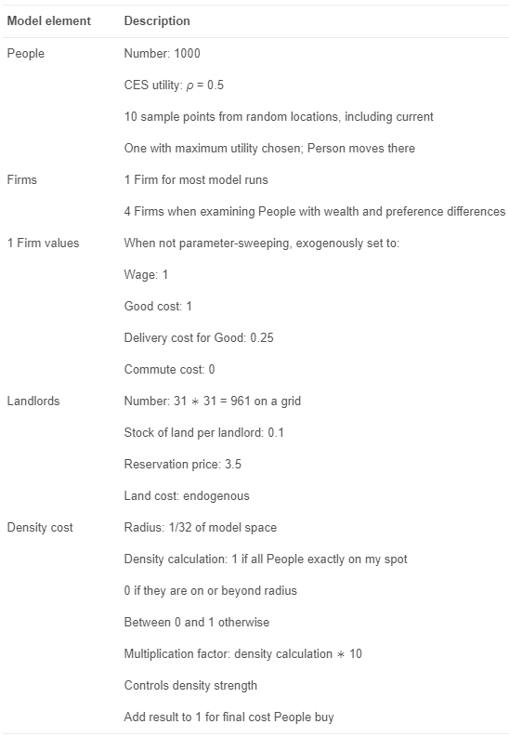

**Change Log**

v1.1

+ density cost works!

v1.09

+ merged with density cost code

+ fixed bug with people moving forever

+ refactored some buggy internal functions

v1.08

+ added crowding for people

v1.07

- updated landlord function needs revising to be more balanced

+ updated search and utility functions

v1.06

+ Added plotting for how many People have the perfect patch for themselves

+ Changed parameters to match Emergence finding

- Need to find balance for spending on goods/land (note at top of code)

v1.05

+ People move based on choice every tick

+ Landlord patch generation quicker

- Choices seem heavily biased towards cheaper land costs (functions need balancing out)

v1.04

+ People's choice of housing movement

- Bug where utility reaches zero mucho quickly

- People seem to be at equilibrium too soon, something wrong with the math

v1.03

+ Fixed bug with £0 land cost patches

+ Fixed bug with patches automatically filling in incorrectly

- Ongoing bug with running people-search

v1.02

+ Added people's choice to move

- Bug with spending on goods function

v1.01

+ Set up Landlord patch ownership

v1

+ Set up firm/people creation